Computer Interface Design Principles

Assignment 1

Jeanette Cutajar

TASK 1 – (P1.1)

***Research the current state of the art with respect to game engines and outline what the most common game engines in use today are. Write a short paragraph explaining at least three interactive game engines with one example of a game from each.***

According to Chris Stead’s article (2009), a game engine is mainly used to provide visual development tools to create and run a game. It gives the creator to develop different elements and tools for a videogame i.e. ultimately composed as one whole functioning game. They are specialized to physics system, sound design, scripting and networking. Nevertheless, game engines are the pillars of contemporary videogame expansion.

There are a large number of engines today such as:

* Game Engine: Source is a type of game engine produces 3D video games, developed by Valve Cororation. Source was created tp power first-person shooters, also been used for role-playing, side scroller, puzzle, top-down shooter, and real-time strategy games. Unfortunately, it does not have a significant version numbering arrangement. In its place it is designed with continuous updates.

Games: Dota 2, Half Life 2 series.

* Game Engine: Glacier 2. The game studio has developed a new technology to capture a more cinematic interactive story to life. IO Interactive created the Glacier 2 engine to bring Hitman’s virtual world to life. This game engine was built to specifically create various and different game features including additional qualities. Every move the player makes is updating in real-time, which is new to the 3D video game world. “Everything in the game now is based on real-time feedback within the game engine,” said Blystad. “

Game: Hitman Absolution

* Game Engine: The Frostbite Engine is a game engine developed by EA Digital Illusions (DICE). It was intended to be capable to render high quantities of “destructible environments” on a large & small measure. It is also includes HDR Sound, which changes volume of sound effects, game music focus more on the vital sounds ex: bullets, explosions, vechicles, etc.

Game: Battlefield

* Game Engine: CryEngine 3 is highly advanced type of system development that exceeds all expectations for the formation of blockbuster games, movies, high quality reproductions, and interactive applications.

Game: Crysis 2 and 3

TASK 2 – (P1.2)

***Explain how different screen sizes are catered for using the Unity game engine, with reference to the ScreenToWorldPoint function.***

function **ScreenToWorldPoint** (position : Vector3) : Vector3

This function altar the position from the screen are to the world are. The screen space is defined in pixels. By using this function it allows you, to get a point X that increases from left to right and Y increasing from bottom to top. Then again the GUI system when it comes to the Y co-ordinates it increases from top to bottom, so you have to invert the Y co-ordinates.

TASK 3 – (P2.1)

***Explain how a simple sound effect is implemented in Unity, with reference to audio listeners.***

Simple steps on how to add a simple sound effect:

1. Drag and drop your audio file into Unity
2. Click on the object/prefab you want to add sound to, Component>Audio>Audio Source
3. Create and Audio Listener
4. Finally drag audio clip into audio source

The Audio Listener performs as a microphone device. It obtains audio input from an Audio Source attached to a game object and plays the sounds through the speakers.

In every scene there can only be one Audio Listener, which is always attached to the Main Camera. When audio is outputted it can be modified using Reverb Zones and other Audio Effects.

TASK 4 – (P2.2)

***Please find Laser sounds found on CD attached to file.***

* Original sound
* Effects added to the sound
* Final modified sound

TASK 5 – (P3.1)

***Explain how to change materials of different objects based on in-game events, with reference to the OnTriggerEnter and OnTriggerExit functions.***

When changing materials using the OnTriggerEnter and OnTriggerExit functions, you must need to make tags to the object. Tags are used to call out the object.

Example:

function OnTriggerEnter(other:Collider)

{

if(other.gameObject.tag=="enemyLaser")

{

//player was hit, reduced health and changed colour

this.renderer.material = spaceshipColours[1];

health--;

}

}

function OnTriggerExit(other:Collider)

{

//when the laser leaves the spaceship, set the colour back to green

this.renderer.material = spaceshipColours[0];

}

TASK 6 – (P3.2)

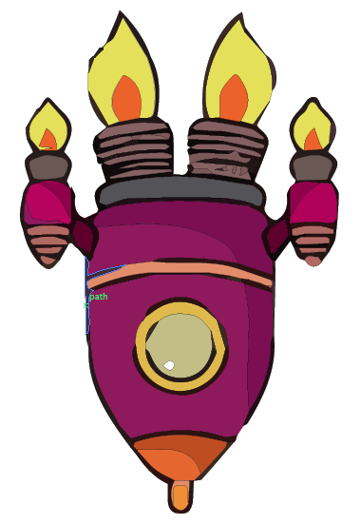***SPACESHIP Sketches***

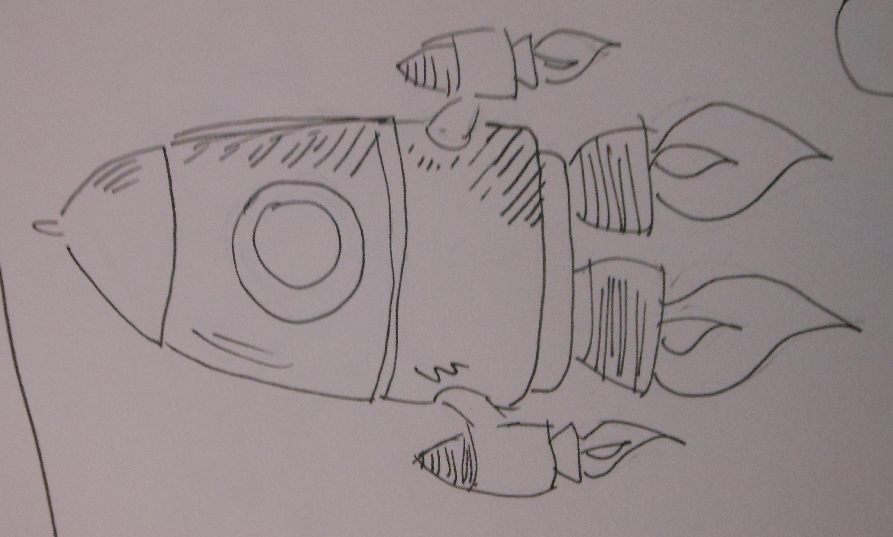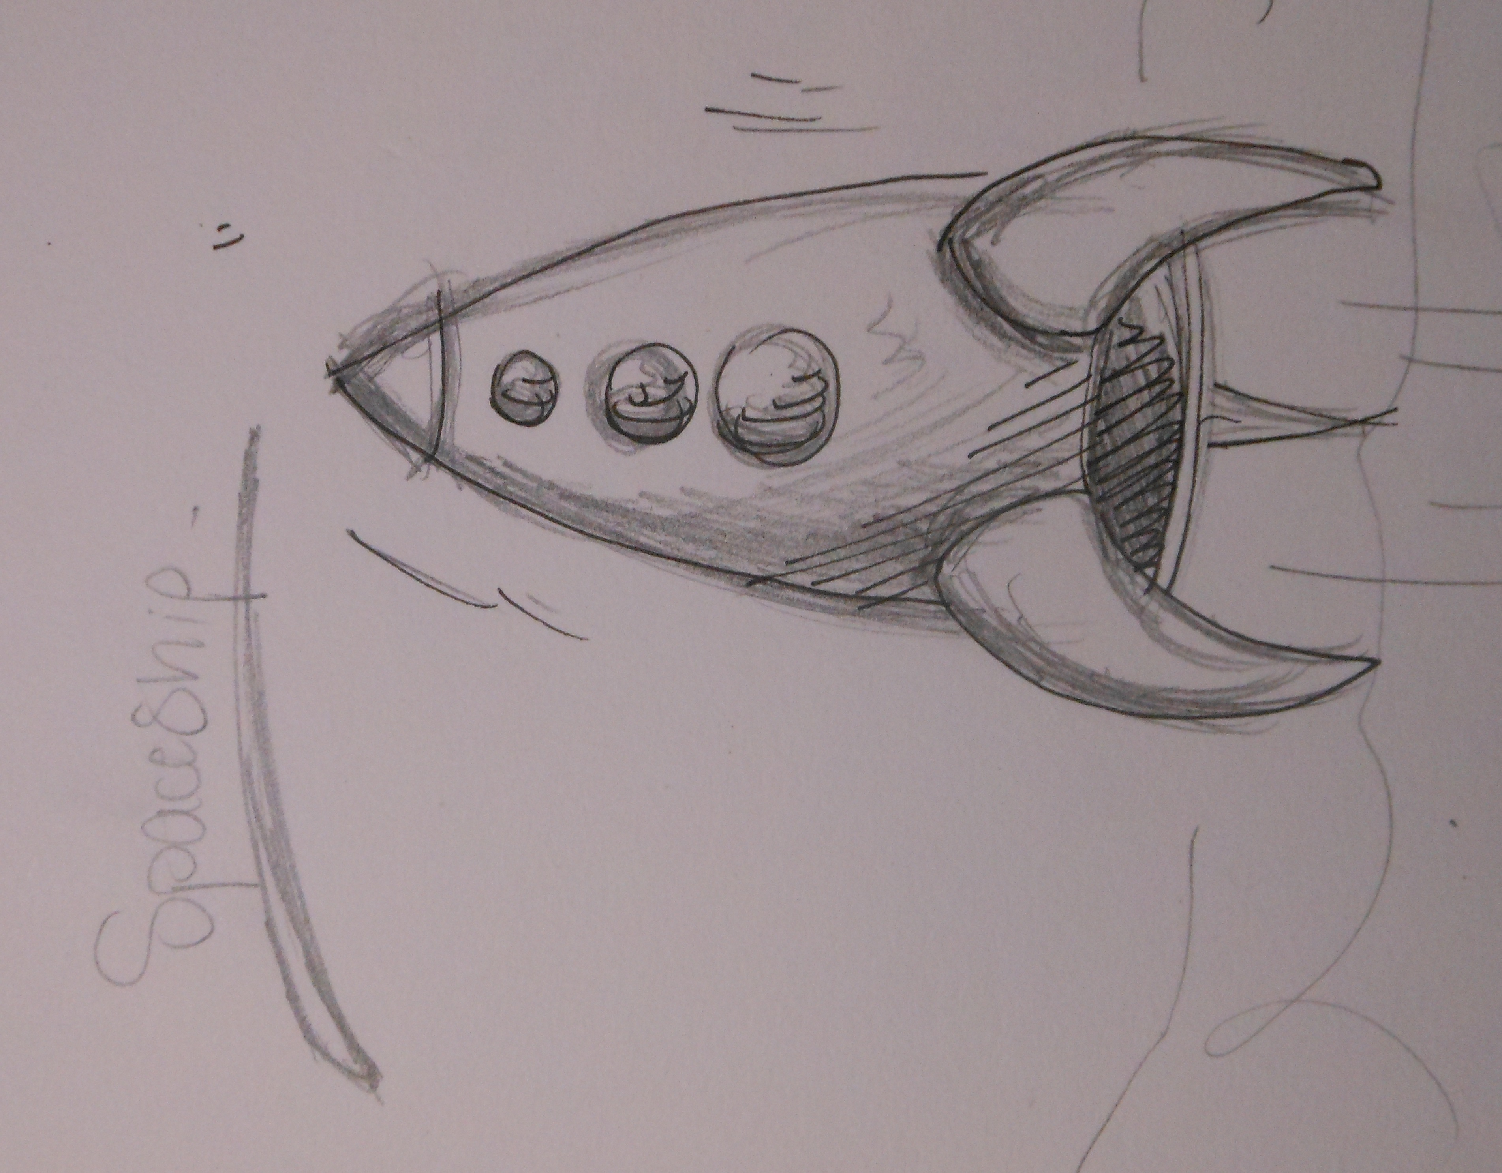

*1st Concept Final Concept*

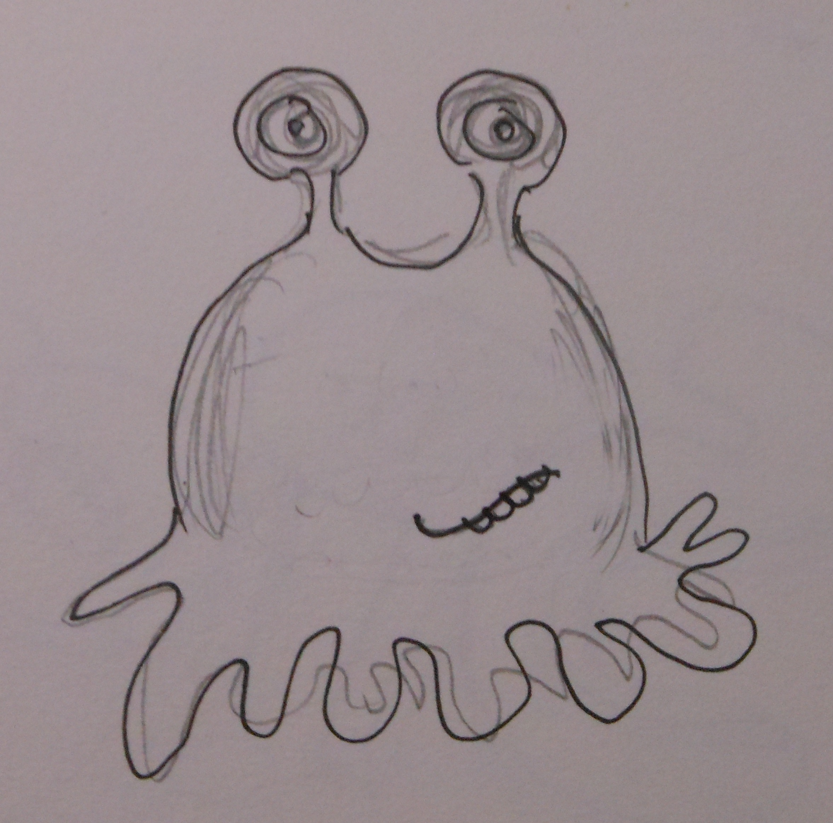

*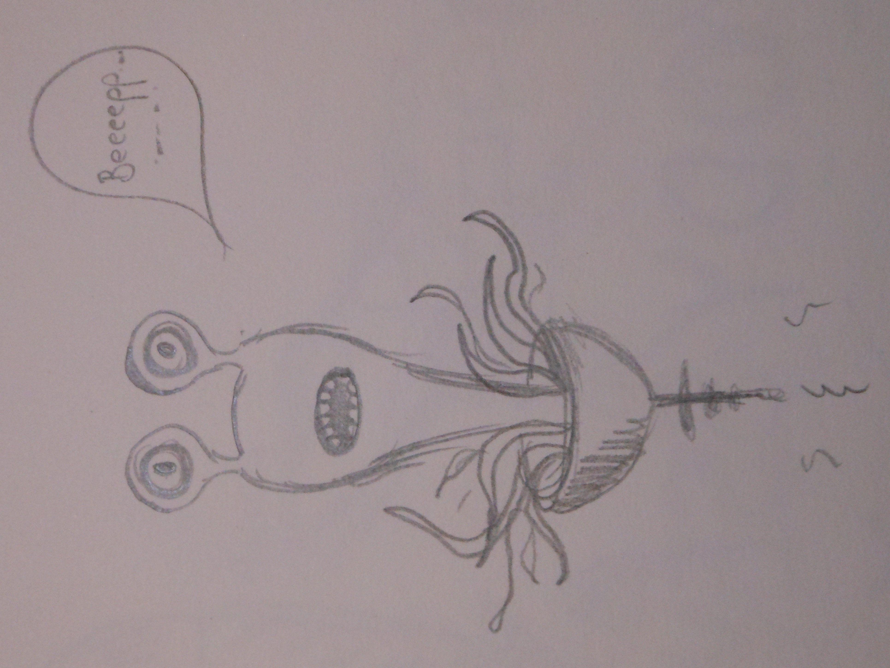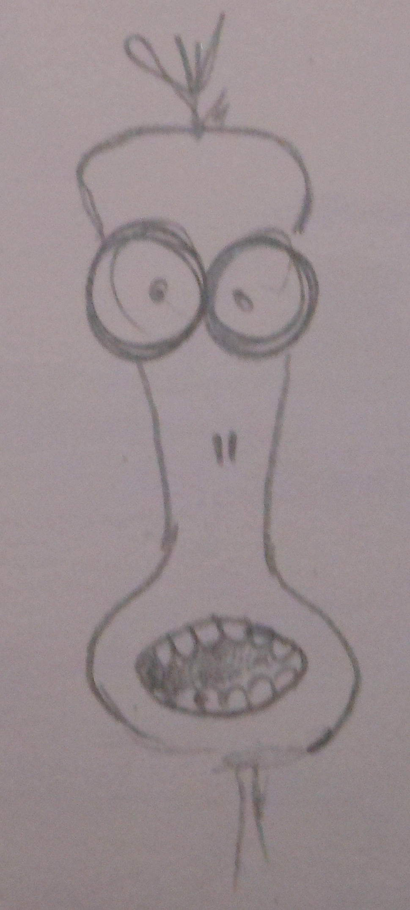****ALIEN Sketches***

*1st Concept*

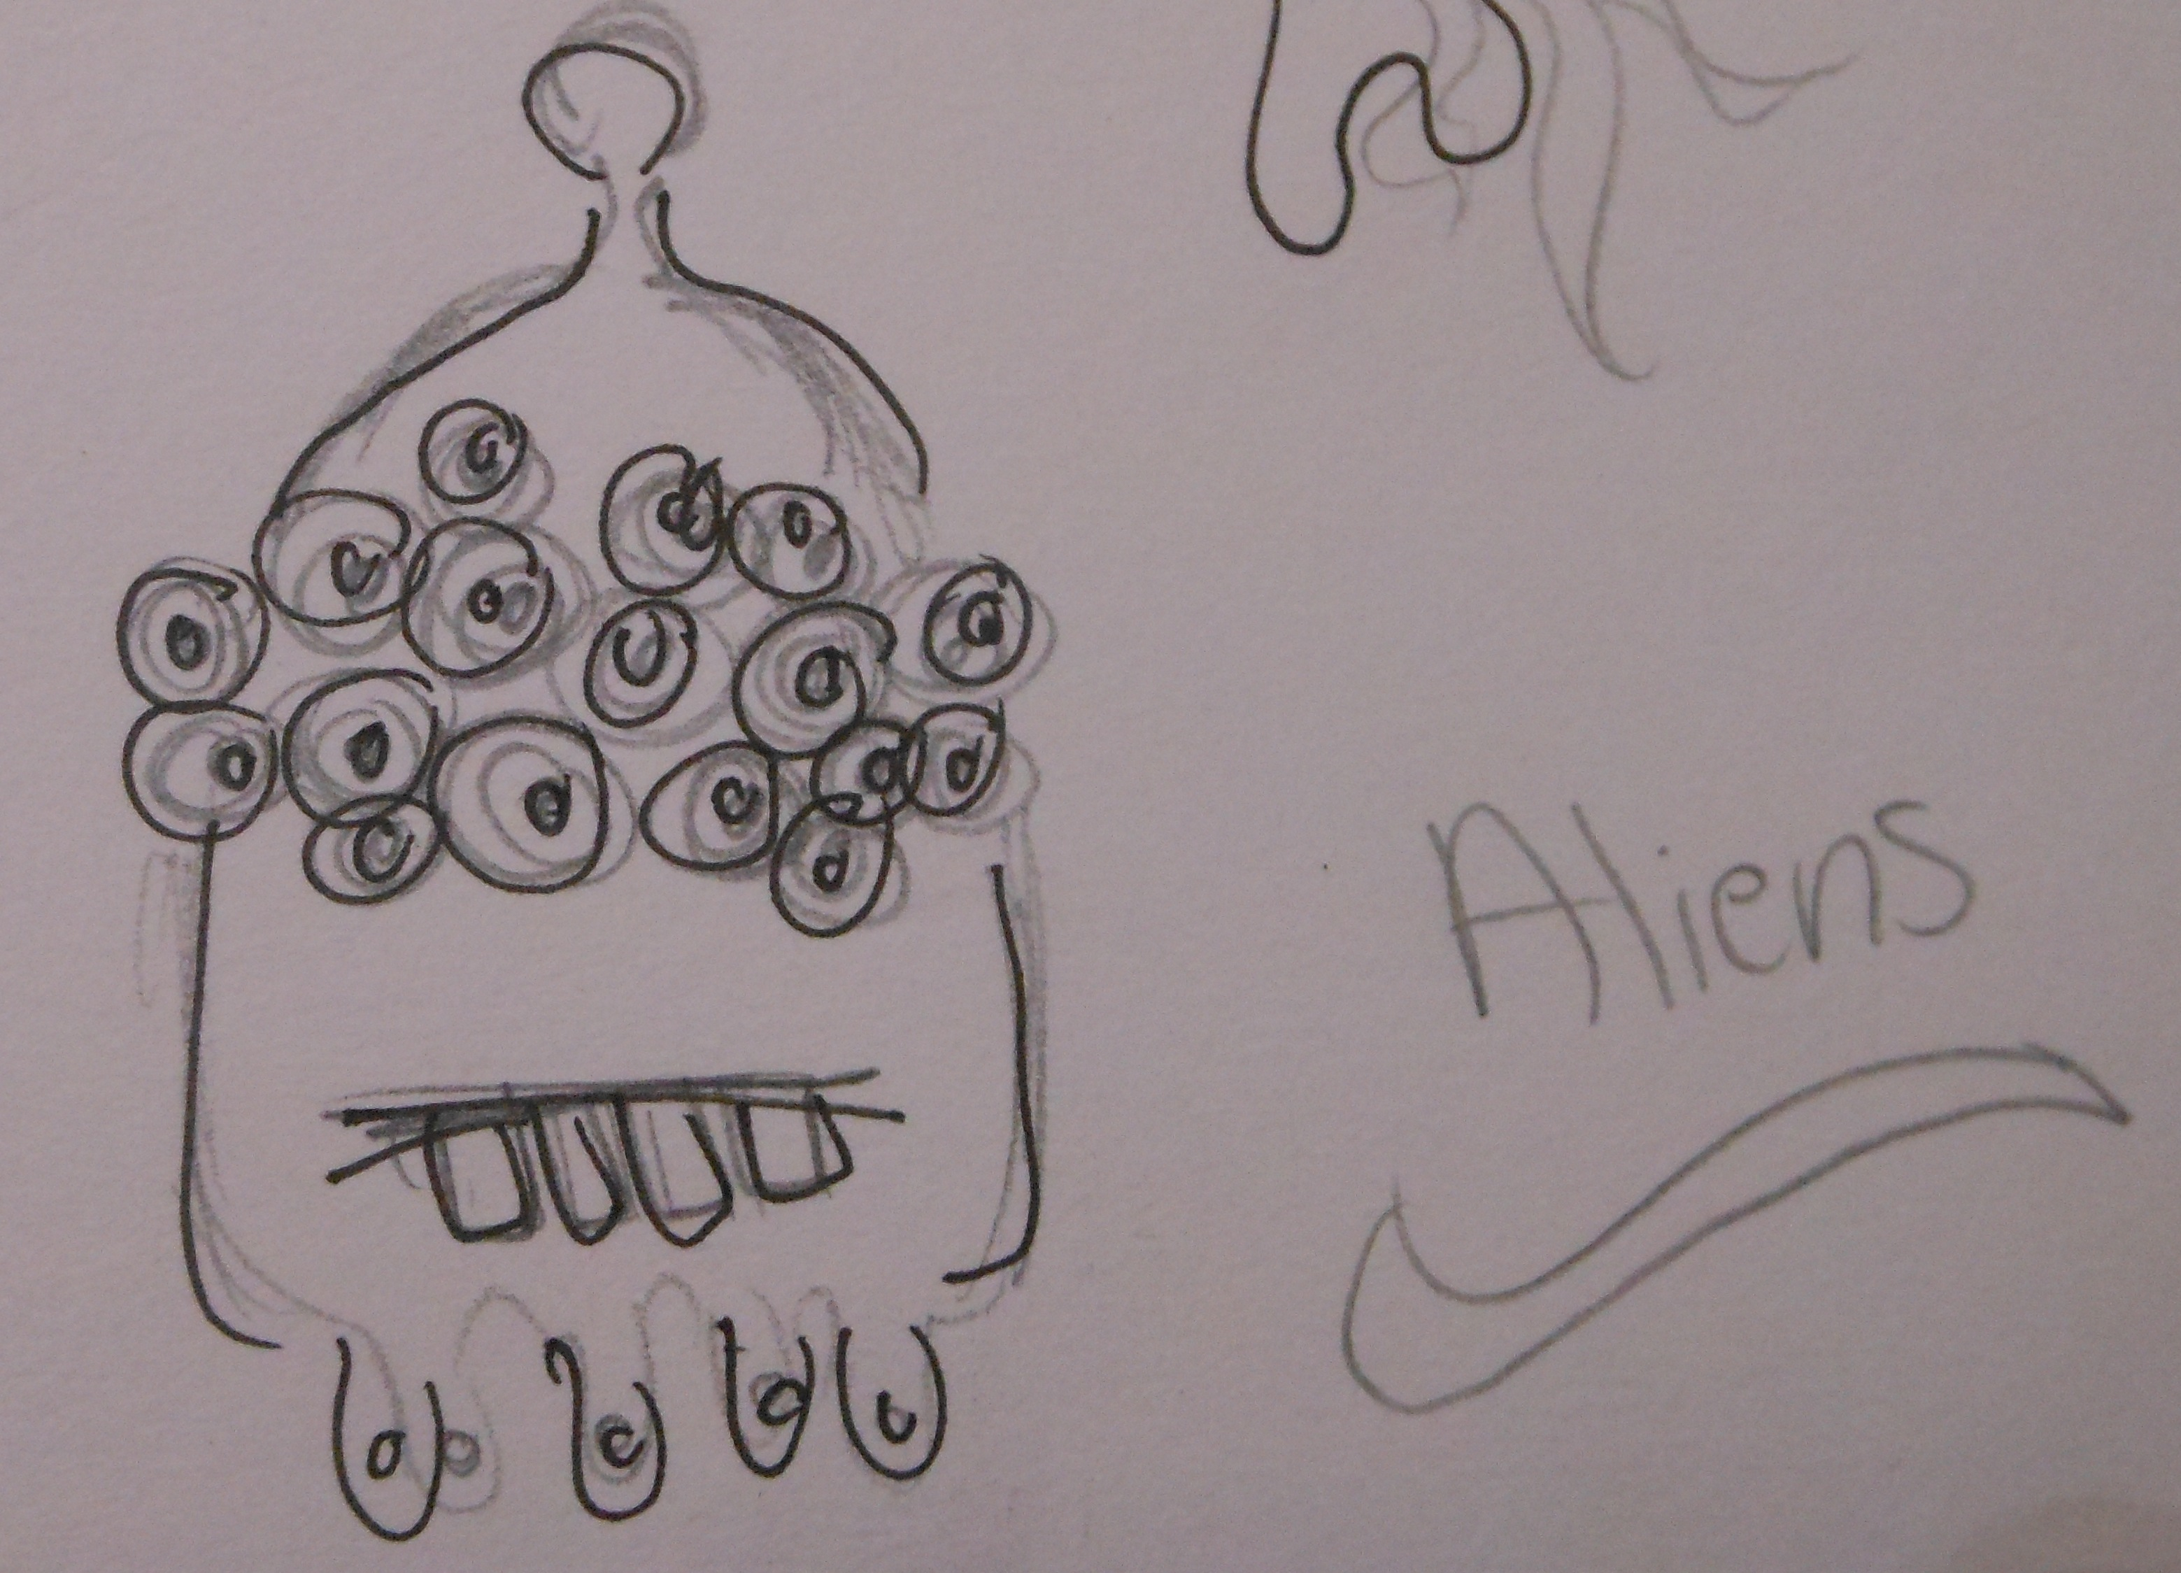

*Final Concept*

***Draw a sketch of three screens of your game:***

*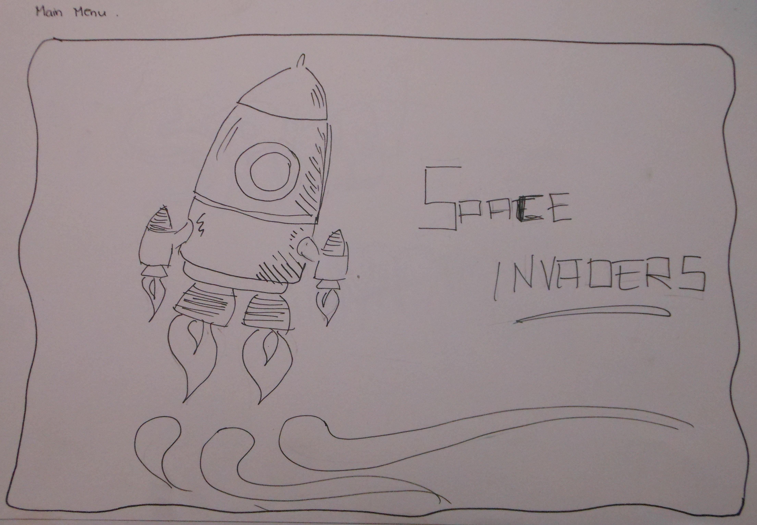Main menu*

*Top scoring*

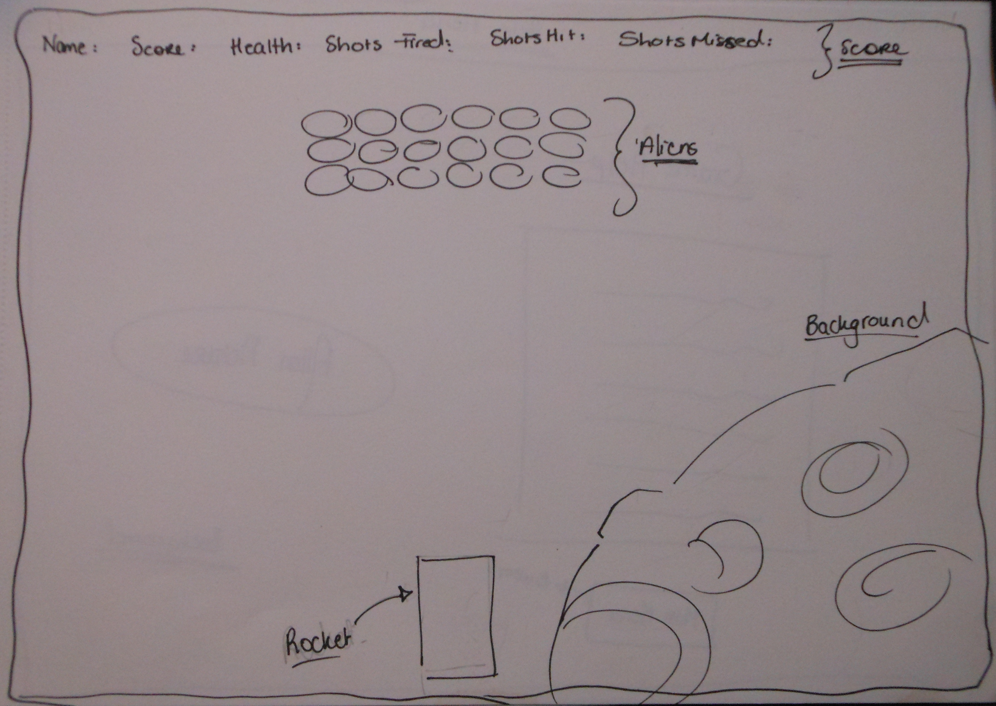

*Game screen*

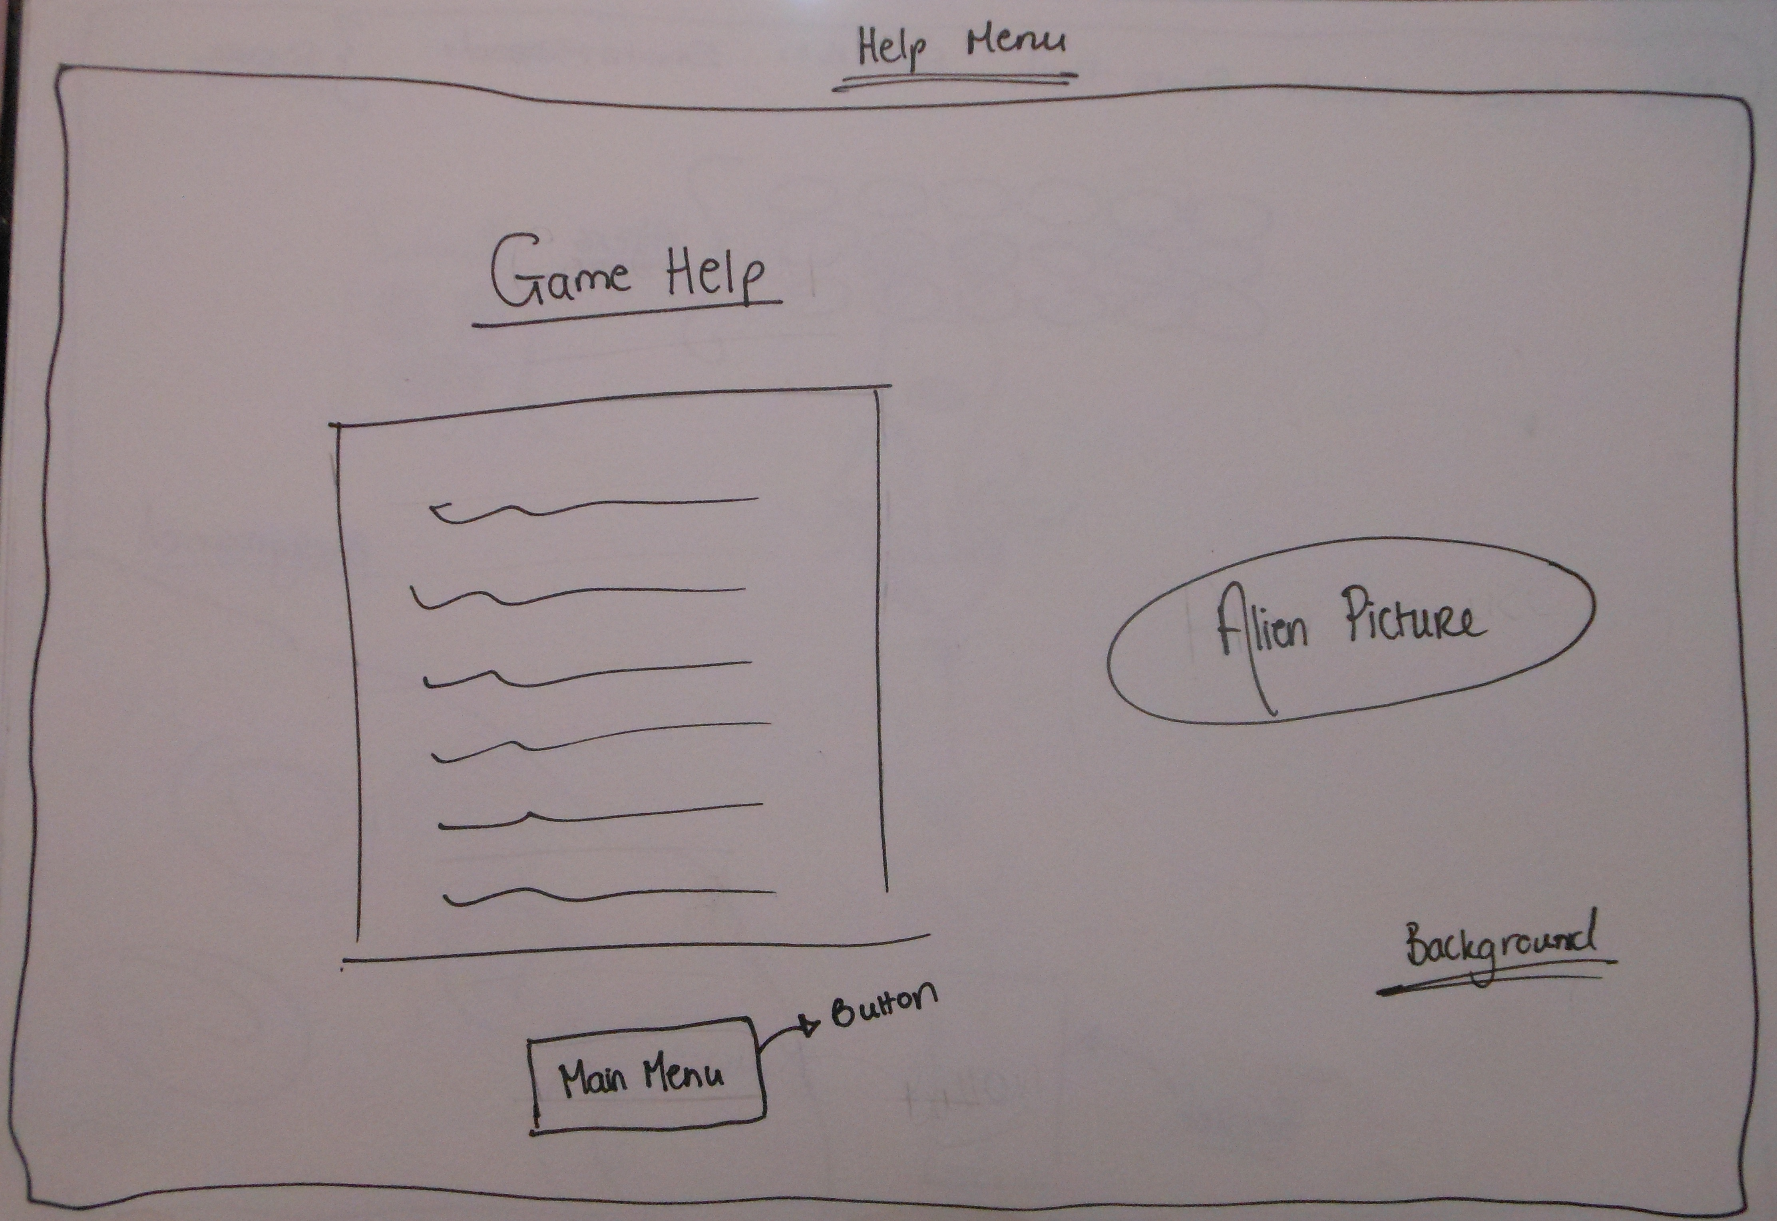

TASK 7 – (P4.1)

***Conceptualize an interactive system by explaining how to interrupt or control a sequence of events using Unity, with particular reference to the start(), update() and WaitForSeconds() methods.***

function Start() : void

The Start function is called first, started all the methods before the Update function. However Start is only called once.

Function Update() : void

The Update function is mostly common when in need to implement a kind of game behaviour.

While the WaitForSeconds() function suspends the coroutine execution for the given amount of seconds.

Example:

// Prints 0

print ([Time.time](http://docs.unity3d.com/Documentation/ScriptReference/Time-time.html?from=WaitForSeconds));

// Waits 5 seconds

yield WaitForSeconds (5);

// Prints 5.0

print ([Time.time](http://docs.unity3d.com/Documentation/ScriptReference/Time-time.html?from=WaitForSeconds));

TASK 9 – (P4.3)

***Write a short paragraph explaining what improvements you would have implemented in the game if you had more time.***

* If I had more time, I would definitely add on each level written level1, level2, level3 for people to know what level they are.
* Would finally add a win scene, once boss is dead, “WINNER!” pops up.
* Score menu were you save your name in and keep data example a “Hightscore”, every time you beat other opponents score.
* Two players instead of just one player.
* Create more sound effects to have a variety to choose from.

TASK 14 – (D1.1) -

*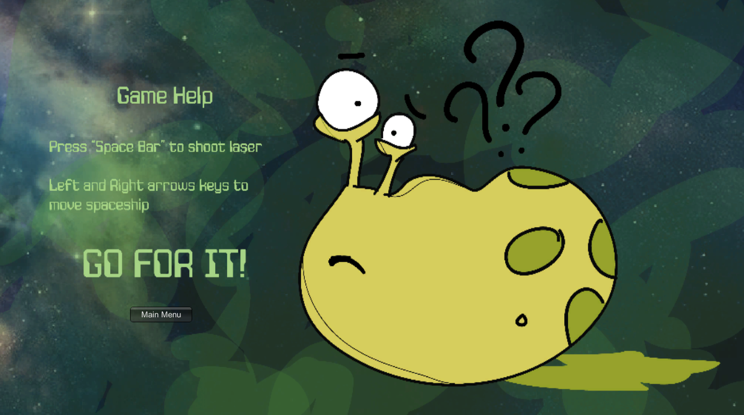Show that conclusions have been arrived at through synthesis of ideas and have been justified by creating a consistent visual theme for the entire game, including fonts and backgrounds. Justify the look of your game against examples of other similar games by including two screenshots.*

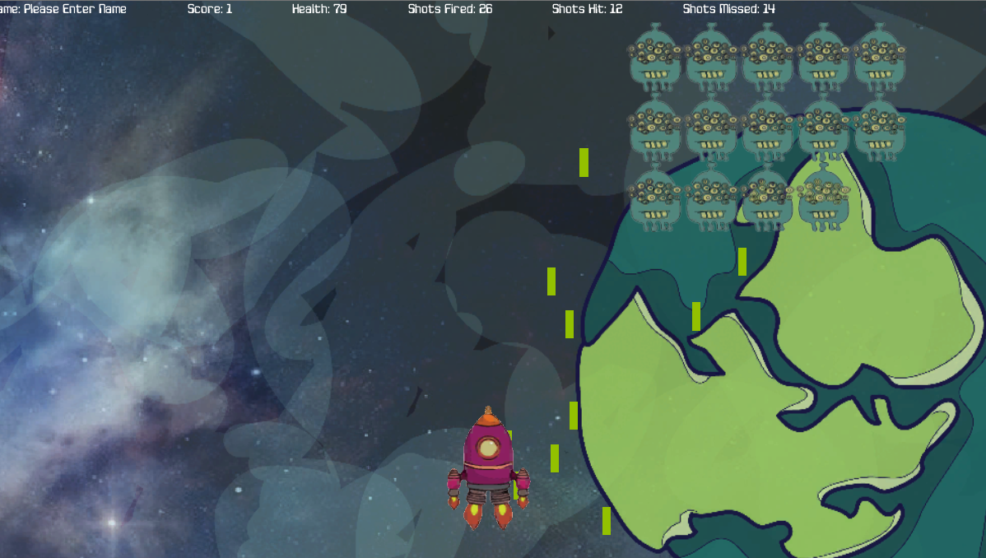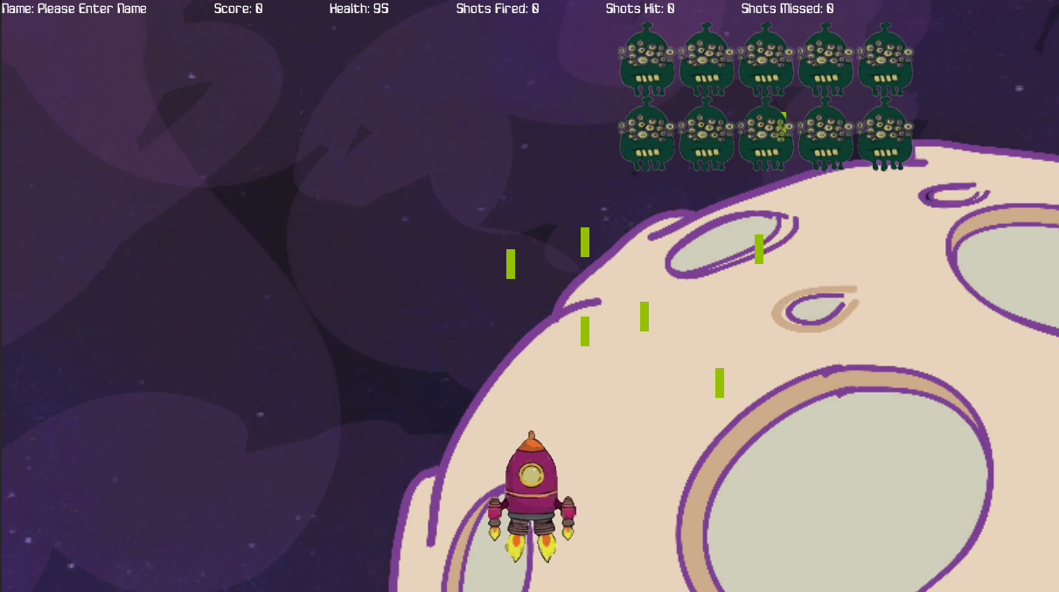

How I developed the whole game (background, fonts, alien and spaceship), looks more fun, cartoonish and modern at the same time. People would love playing this game therefore without an attractive game, you’ll end up with an unhappy client.

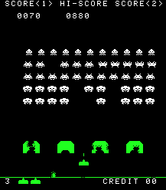On the other hand, images showing below show another type of Space Invaders. In my opinion it need more life to it, example, effects, colour, backgrounds etc.

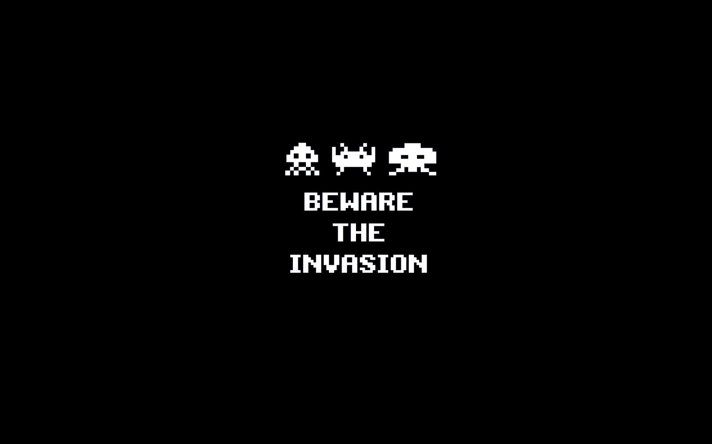

TASK 15 – (D2.1)

***Please find Laser sounds found on CD attached to file.***

*Show that the importance of interdependence has been recognized and achieved by recording at least three different and appropriate sound effects for your game. You must include the following for the three different sounds:*

* *The original sound*
* *Any sound effects applied*
* *The final sound*

References

<http://www.ign.com/articles/2009/07/15/the-10-best-game-engines-of-this-generation>

<http://www.dreamincode.net/forums/topic/232020-what-exactly-is-a-game-engine/>

<http://docs.unity3d.com/Documentation/Manual/index.html>